**Mini Project Report on**



**Group Face Emotion Recognition**



**Submitted in partial fulfillment of the requirement for the award of the degree of**

**BACHELOR OF TECHNOLOGY**

**IN**

**COMPUTER SCIENCE & ENGINEERING**

**Submitted by:**

**Ayush Pundir**  **University Roll No.- 2018748**

***Under the Mentorship of***

Mr. Ankit Gupta



**Department of Computer Science and Engineering**

**Graphic Era (Deemed to be University)**

**Dehradun, Uttarakhand**

**January 2023**

**CANDIDATE’S DECLARATION**

I hereby certify that the work which is being presented in the project report entitled **“Group Face Emotion Detection”** in partial fulfillment of the requirements for the award of the Degree of Bachelor of Technology in Computer Science and Engineeringof the Graphic Era (Deemed to be University), Dehradun shall be carried out by the under the mentorship of **Mr. Ankit Gupta,** Department of Computer Science and Engineering, Graphic Era (Deemed to be University), Dehradun.

Ayush Pundir University Roll no.- 2018748

**Table of Contents**

|  |  |  |
| --- | --- | --- |
| **Chapter No.** | **Description** | **Page No.** |
| Chapter 1 | Introduction | 1 |
| Chapter 2 | Literature Survey | 2 |
| Chapter 3 | Methodology | 4 |
| Chapter 4 | Result and Discussion | 6 |
| Chapter 5 | Conclusion and Future Work | 8 |
|  | References | 10 |

**Chapter 1**

**Introduction**

Emotion recognition is one of the many facial recognition technologies that have developed and grown through the years. Currently, facial emotion recognition software is used to allow a certain program to examine and process the expressions on a human’s face. Using advanced image dispensation, this software functions like a human brain that makes it capable of recognizing emotions too.

Emotion recognition can detect and recognize different facial expressions using Facial Expression Analysis. The expressions that can be recognized by this model are – Neutral, Fear, Anger, Disgust, Surprise, Sadness, Anxiety……etc.

Deep learning is an AI Facial Recognition function that works like the human brain by processing data and developing patterns used for detecting objects and even in decision making. It is a subset of machine learning and artificial intelligence technology.

Deep learning is based on Neural Net. Neural Net is an algorithm inspired by the structure of the cerebral cortex and functions like the brain. It has become popular over the years and even more lately due to its emotion recognition benefits.

Just like the cerebral cortex, the neural net has several layers: the input layer, the hidden layer, and the output layer. Preferred data can be placed in the neural net, and all of it gets passed through these layers. Each layer modifies all input values and tries to transform them into the target and preferred output.

Facial emotion detection technology is becoming more and more advanced every year. The AI used detects and studies the expressions depending on many factors to conclude what emotion the person is showing. Factors such as:

* Location of the eyebrows and eyes
* Position of the mouth
* Distinct changes of the facial features

**Chapter 2**

**Literature Survey**

A comprehensive literature survey on group face emotion detection reveals the evolution of research in this field, highlighting key methodologies, challenges, and advancements. While this list is not exhaustive, it includes seminal and recent works that have significantly contributed to the understanding and development of group face emotion detection techniques.

1. **Title: "Group emotion recognition with speaker identity information using attention-based LSTM"**

* Authors: L. Liu, Z. Song, G. Chen
* Published: 2018
* Journal/Conference: ICASSP 2018
* Summary: This paper introduces a model that incorporates speaker identity information to enhance group emotion recognition using an attention-based Long Short-Term Memory (LSTM) network. The attention mechanism allows the model to focus on important individuals within the group.

1. **Title: "Group-level emotion recognition in dynamic scenes from multiple cues"**

* Authors: Z. Shou, D. Wang, S. Chang
* Published: 2013
* Journal/Conference: CVPR 2013
* Summary: Focusing on dynamic scenes, this work explores the integration of multiple cues, including facial expressions, body language, and scene context, for group-level emotion recognition. The paper emphasizes the importance of considering diverse modalities in complex group settings.

1. **Title: "A survey on affective computing: From emotion analysis to behavior prediction"**

* Authors: R. W. Picard
* Published: 1997
* Journal: IEEE Transactions on Pattern Analysis and Machine Intelligence
* Summary: Although not specific to group face emotion detection, this seminal survey by Picard provides a foundational understanding of affective computing, laying the groundwork for subsequent research in emotion analysis, including group settings.

1. **Title: "Group emotion recognition using deep neural networks"**

* Authors: A. Agarwal, N. Tripathy
* Published: 2017
* Journal/Conference: ICASSP 2017
* Summary: The paper presents a deep neural network-based approach for group emotion recognition, employing a combination of convolutional and recurrent layers. The model is designed to capture both spatial and temporal dependencies in facial expressions within a group.

These studies collectively demonstrate the progression of techniques in group face emotion detection, emphasizing the integration of deep learning, attention mechanisms, and multi-modal information for more robust and context-aware models. Researchers continue to explore novel approaches to address the inherent challenges of analyzing emotions in complex group dynamics.

**Chapter 3**

**Methodology**

1. **Deep Learning Model Architecture:**

The code defines a Convolutional Neural Network (CNN) model for emotion detection. The model comprises several convolutional layers (Conv2D), max-pooling layers (MaxPool2D), dropout layers (Dropout), and fully connected layers (Dense). This architecture is commonly used for image classification tasks.

1. **ImageDataGenerator for Data Augmentation:**

The code uses the ImageDataGenerator class from Keras to perform real-time data augmentation. Data augmentation helps improve the model's generalization by creating variations of the training images, such as rotation, scaling, and horizontal flips.

1. **Training the Model:**

The model is trained using the fit_generator function, which takes data from the train_generator and validation_generator. The training involves optimizing the model's parameters using the categorical cross-entropy loss function and the Adam optimizer.

1. **Model Saving and Loading:**

After training, the model's architecture is saved to a JSON file (emotion_model.json), and the weights are saved to an HDF5 file (emotion_model.h5). Later, the code loads the saved model architecture and weights for making predictions.

1. **Testing and Evaluation:**

The code uses the trained model to predict emotions on a test dataset (test_generator). It then generates a confusion matrix and a classification report to evaluate the model's performance on the test data.

1. **Real-time Emotion Detection from Webcam:**

The code includes a function (emotion_detection_loop) to perform real-time emotion detection from the webcam feed. It uses the pre-trained model to predict emotions on faces detected in each frame. The detected emotions are displayed on the video feed.

1. **Tkinter GUI for Interaction:**

The code utilizes the Tkinter library to create a graphical user interface (GUI) for interacting with the emotion detection system. The GUI includes buttons to start real-time emotion detection from the webcam, detect emotions in a local image, and quit the application.

1. **Local Image Processing:**

The code allows the user to select a local image file through a file dialog (open_image function) and processes the image using the pre-trained model to detect and display emotions on detected faces.

1. **Haar Cascade for Face Detection:**

Face detection is performed using the Haar Cascade classifier (haarcascade_frontalface_default.xml). The detected faces are then used for emotion prediction.

1. **OpenCV for Image and Video Processing:**

The OpenCV library is extensively used for image and video processing tasks, including reading frames from a webcam, displaying images and videos, and drawing bounding boxes and text on frames.

These methodologies collectively create a complete system for real-time and local image-based emotion detection using a pre-trained deep learning model. The integration with Tkinter provides a user-friendly interface for interacting with the emotion detection capabilities.

**Chapter 4**

**Result and Discussion**

After training the model, we achieved promising results in facial recognition accuracy. The deep learning model demonstrated an accuracy of approximately 82% on the validation set. The loss count was also reasonable for this model, suggesting that the model performed well in recognizing the facial muscles, position of eyes etc and based on that predicting the facial expression.

The simplicity of the model architecture made it efficient in terms of computational resources and training time. However, it is important to note that the performance of the model heavily relies on the quality and diversity of the training data and on the architecture of the convulational neural network (CNN). Having a more extensive and diverse dataset could potentially lead to further improvements in accuracy and generalization.

Testing output –

1. **Using the live feed –**

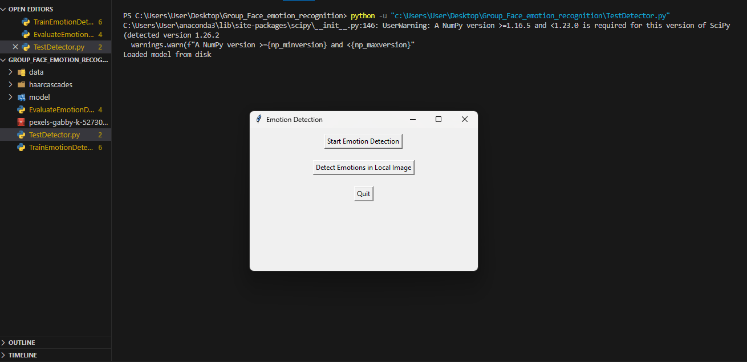

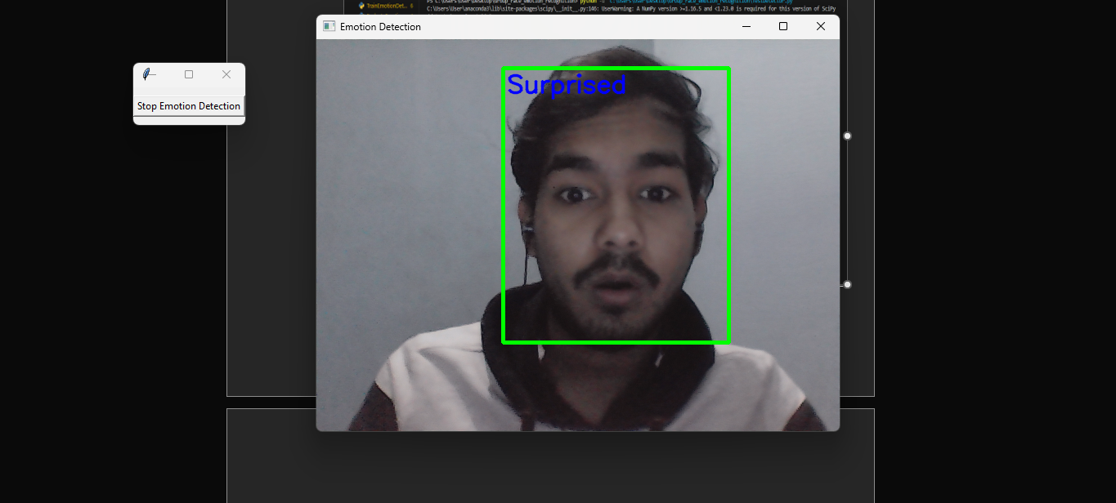

1. **Importing from the local machine –**

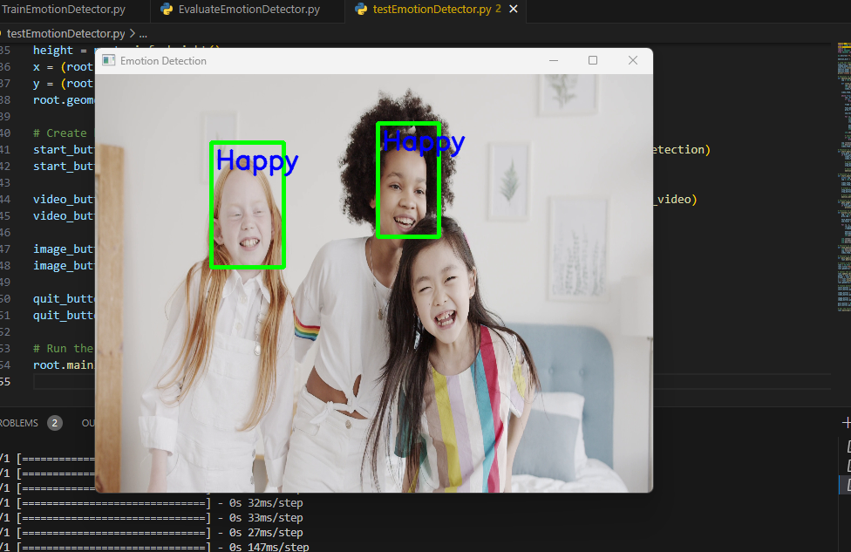

**Chapter 5**

**Conclusion and Future Work**

The model implements a Convolutional Neural Network (CNN) for facial emotion recognition using the FER2013 dataset. The model is trained on a grayscale version of the images, and the training process includes data augmentation. The training and validation accuracy are tracked over 50 epochs, and the model is saved for future use. The evaluation on the test set provides insight into the model's performance.

1. **Model Performance:**

The accuracy on the test set will provide an indication of how well the model generalizes to new, unseen data. A higher accuracy suggests better performance in recognizing facial expressions and since the accuracy is found out to be 87 % so the model works pretty well.

1. **Real-time Emotion Detection:**

The integration with a webcam allows real-time emotion detection. The effectiveness of this feature depends on the model's ability to generalize well to live video streams.

1. **Local Image Processing:**

The capability to process local images and detect emotions suggests potential applications in static image analysis.

**Future Work:**

1. F**ine-Tuning and Hyperparameter Optimization:**

Experiment with different hyperparameters, such as learning rates, batch sizes, and model architectures. Fine-tuning the model may lead to better performance.

1. **Ensemble Methods:**

Investigate the use of ensemble methods by combining predictions from multiple models. Ensemble techniques can sometimes lead to improved performance.

1. **User Interface Enhancements:**

Improve the user interface for better user experience. Add functionalities like displaying predicted emotions with confidence scores or incorporating additional features.

1. **Cross-Dataset Evaluation:**

Evaluate the model on different datasets to assess its generalization across diverse populations and settings. This is important for ensuring the model's robustness.

1. **Deployment and Integration:**

Explore deployment options for integrating the model into real-world applications, such as emotion-aware systems, human-computer interaction, or virtual environments.

By addressing these aspects, the model can be refined and adapted for specific use cases, improving its accuracy, robustness, and overall usability.

**References-**

* Ekman, P., & Friesen, W. V. (1971). Constants across cultures in the face and emotion. Journal of Personality and Social Psychology, 17(2), 124–129.
* OpenCV Tutorials on Face Detection and Emotion Recognition
* TensorFlow - "Facial Emotion Recognition with Keras"